 | EUROPEAN COMMISSION  DIRECTORATE-GENERAL  INFORMATICS  Infrastructure and Logistics Directorate  Technical solutions and office systems | 

European Commission
E-TrustEx Adapter 2.0 Architecture

Date: | 20/11/2015
Version: | 1.2
Authors: | Valer Micle
Revised by:
Approved by:

Contents
- 1. Leos Components Structure 4
- 2. Project set-up 5
2.1. Pre-requirements 5
2.2. Technologies to use: 5
2.3. Project structure 5
2.4. Testing: 7
2.4.1. Java code testing 7
2.4.2. Javascript testing 8
- 3. Deployment 8
- 4. Development principles 8
- 5. Components architecture 9
5.1. Web component 9
5.1.1. Implementation Strategy 9
5.1.2. JavaScript 11
5.1.3. Styles 13

Document History

Version | Date | Comment | Modified Pages
0.1 | 04/10/2013 | Creation | All
0.2 | 16/10/2013 | Provide the web-architecture | 8-11
0.3 | 07/11/2013 | Include the remarks received during the review phase | All
1.0 | 15/11/2013 | Mark the document as final | None
1.1 | 31/01/2014 | Describe the javascript structure and implementation approach under section 5.1.2 | 11,12, 13
1.2 | 20/11/2015 | Describe the javascript structure and implementation approach under section 5.1.2 | 11, 12, 13

Leos Components Structure
Leos will be divided into 3 major tires: presentation, business and data tire.
Below is depicted in a diagram the internal structure of Leos including the dependent nodes from the Data Tire.
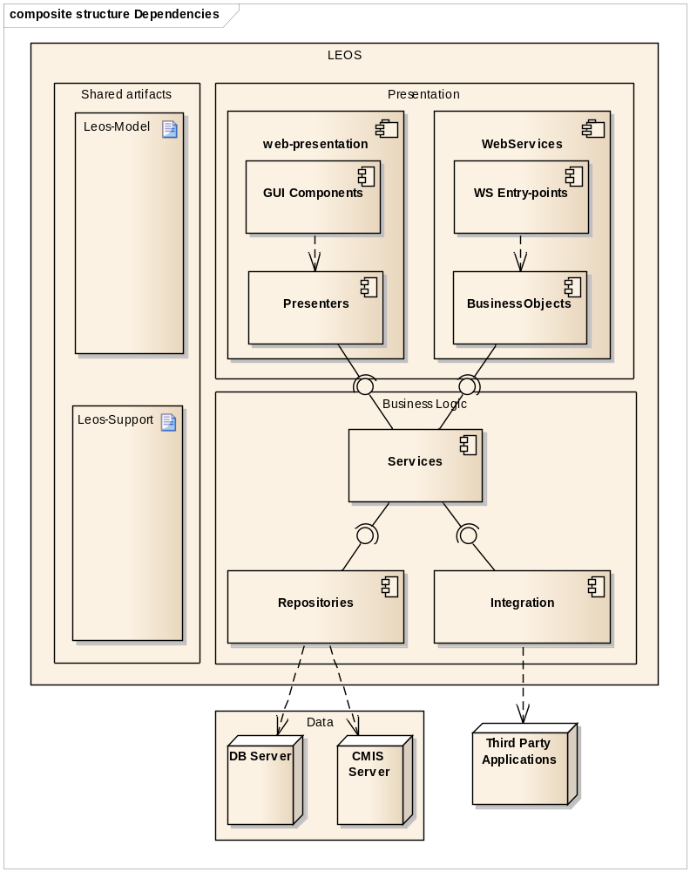
There are two special artifacts that can be noticed:
- model – includes all the classes for application's persisted data that will be accessible across all layers
- support – includes functions useful in multiple places that are not directly bound to a special layer or component and it can be reused on any places across the application without restrictions
The layers inside the Leos application are spread across two tires: presentation and business logic tire.
The layers included in the presentation tire are:
- GUI components (web-presentation) – groups all the UI related components (screens, components, windows)
- Presenters (web-presentation) – encapsulates all the logic for web-actions: calls specific services from business logic layer and prepares the required data for the next GUI component
- WS Entry-points (WebServices) – validates the input data and calls specific BusinessObjects to execute the actual logic if the input is valid and the caller has access to the requested function
- Business Objects (WebServices) – calls specific services from business logic layer and prepares the required data for the response (if any)
The Business logic tire includes the following layers:
- Services –it encapsulates all logic for handling various requests
- Repositories – hold the read/write access to all the data used by the application
- Integration – encapsulates all the logic for accessing third party applications
The data tire holds all our data and is accessed by the repositories layer. The two servers holding the application's data are a DB server and CMIS Server. Application's data are divided between the two server based on the data's purpose:
- DB Server – holds all the data required for the application to run (users, configurations, documents metadata, etc)
- CMIS Server – holds the documents content

Project set-up

Pre-requirements
General development pre-requirements:
- set-up a database that can be access by looking up the JNDI name jdbc/leosDB
- set-up the build tool (maven) for assembling the defined module in a war package
- read the WIKI page Leos – Development in order to see how you must configure Maven/Database/Application server.. etc

Technologies to use:
- Vaadin 7
- Spring for wiring
- Spring data - jpa
- Hibernate
- CMIS
- WS-Provider: JRC standard for REST
- Mockito
- CkEditor

Project structure
The following folder structure is defined at project level:
- database - contains the database utilities for doing create/drop database
- modules - contains all the project modules
- docs – contains all the documentation of the project
- etc – holds configurations for IDEs that can be shared across the team
- cmis – contains a convenient CMIS server to be used during development
The modules folder is a maven module contains all the modules where the programming activity will take place. Each of these modules will have a similar structure like the one shown below for the service module:
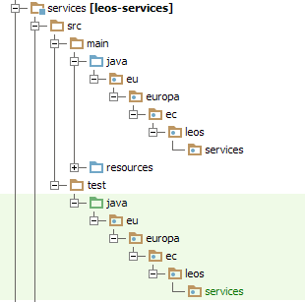
All modules will depend on the model module and, if necessarily, on the support module.
The below diagram depicts all the programming modules and the dependencies between them. In order to have the diagram clearer, the dependency between all modules and model/support module was not depicted in the diagram.
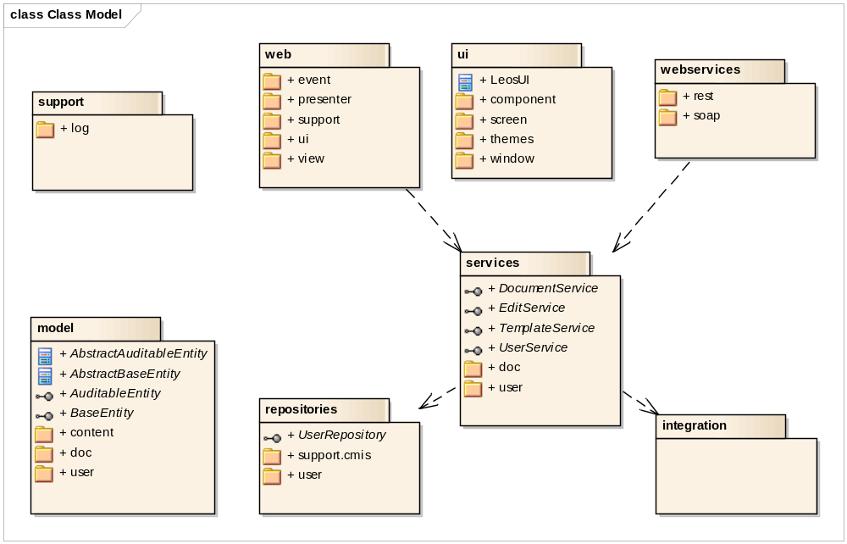
- Module web – contains all the web implementation; depends on the model and services modules
- Module web-services – contains the web-services that leos provides; it has a different package for SOAP and REST based ws; it depends on the model and services modules
- Module model – it contains all the model related objects (Pojos); it defines classes for all persisted data used inside the application; it has Value Object classes for transferring data for which we don't have an entity
- Module services – is the entry-point inside the application's back-end; it has dedicated services for handling the editing, template users, etc; it has a LeosException (runtime exception) that could be thrown by different back-end modules. TBD: should we put it in the support module?
- Module repositories – it contains at first level the interfaces that we need to load the model objects; it has a support.cmis package to hold the implementation with OpenCMIS
- Module integration – contains the integration functionality (if any)
- Module support – contains all the support related functionality. Please note that this should be logic that can be used across all modules and not specific to a given module!

Testing:
Testing is required for all modules except the parts which deal directly with building the UI (GUI components, themes, screens).

Java code testing
For all java code except the web.ui package JUnit tests must be written so that the code coverage is of at least 80%.
Test must be created in the same package structure as the class that is tested but under the test folder. For each class being tested, the name of the test will be the name of the class appended by the Test suffix like it can be seen in the below example for the test corresponding to the UserServiceImpl class:
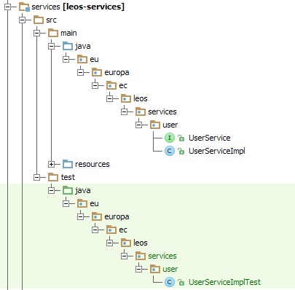
The naming of each test method must follow the following pattern:
test_methodName_should_expectedBehaviour_when_specificConditionTested
Note that the parts should and when must not be included when they are not suitable. For example it makes no sense for a test method corresponding to findAllUsers which does a simple redirect between layers to have a when condition.
In order to easily see what is the tested method, add all the time a comment just before the call to the method being tested like this:
//DO THE ACTUAL CALL
testedClass.callTheTestedMethod();

Javascript testing
For Javascript, the testing is made using jasmine.
The JS-test files should have the same name as the JS files suffixed with ‘Spec’ so that jasmine will recognise them. They should be in the same package structure as the JS-files but under src/test/javascript. There should be one test method (it) per test case.

Deployment
Each module except the web module will be built as a jar. The packaging will be made as a single war and all the jars corresponding to the Leos modules will be copied as dependencies.
The resulting WAR archive will be deployed in a JEE 5 compliant application server.
In order to run the application, a database and a CMIS server are required (to be specified what servers and how to set them up).
The below image shows the deployment nodes required to run Leos application.
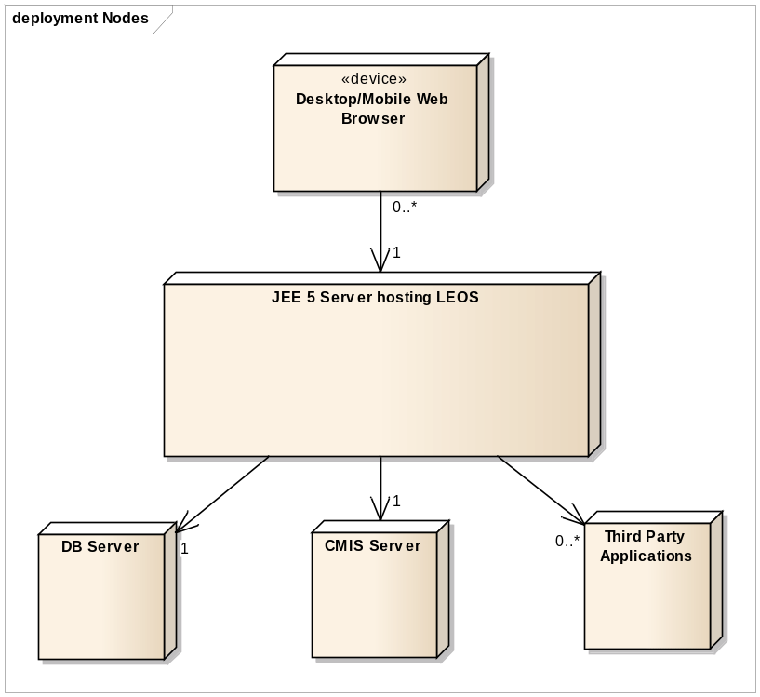

Development principles
Based on the discussions with the development team, the following development principles were defined for the Leos Prototype:
- all interface methods must have java-docs
- the implementation methods must have java-docs where the logic tends to be complex
- with spring data do not use named queries nor JPA criteria queries. Use only query annotation and very limited method name based query
- tests must be written for all classes except those under the package web.ui
- read the WIKI entry for code style in order to be sure that what you develop will be in line with everybody else format
- VO objects should be made immutable to enforce the notion of read-only objects
- model entity classes should avoid having equal methods due to the big pitfalls that this method could have
- all service methods must be transactional. A transaction must be started all the time for each type of operation

Components architecture

Web component

Implementation Strategy
The web is using the MVP (Model-View-Presenter) pattern, the Supervising Controller variant. The below diagram depicts the interactions that exist in Leos using the MVP-SC strategy:
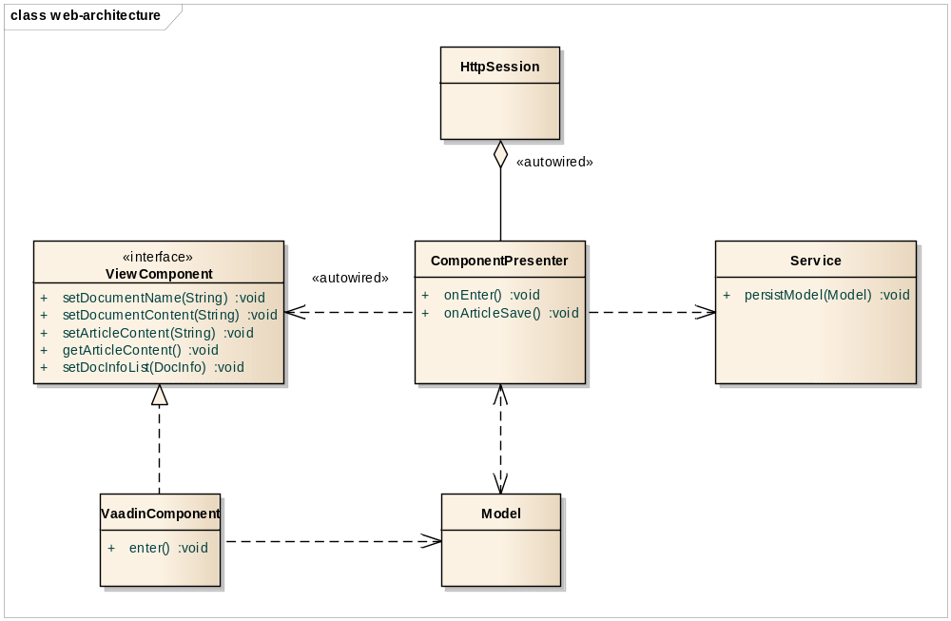
The purpose is to decouple the building of the view from the logic around the view. Moving all the logic of handling user events inside the controller will enable us to unit-test the behaviour of the view and to have a clean separation of concerns.
Here is a diagram showing the components behaviour when the user executes an action that requires reading data from the model and passing them to the view.
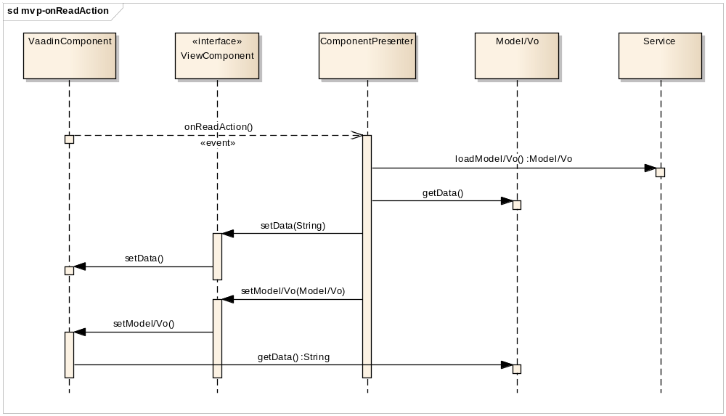
Let us now detail the behaviour of the model, view and presenter based on the above diagram.
Views – passive interface that displays data (from the model) and sends user actions (events) to the presenter to act upon data.
The view is composed from an interface that the presenter acts upon and the actual implementation. Since the implementation is realizing the contract of the view interface, the framework used to create the view can be changed at any moment in time without having to touch neither the presenter nor the model.
The view never decides what it should do with user's actions but instead it fires events corresponding to user's actions without knowing who will handle them. Actually, the view does not depend on the presenter directly. It is up to the presenter to listen for those events and to handle them accordingly. As such, during the view implementation, the focus can be fully channelled on what it needs to be displayed without asking yourself how you obtain the data that needs to be displayed or how user's actions are handled.
Model – contains the data that the view should display, either pushed by the presenter directly into the view, either read by the view from the model exposed by the presenter.
Presenter – Act upon model and view interface and decides about the navigation/notification/otherGlobalFunctions. It does not depend on the view implementation or on the framework used for the UI. It loads the model from repositories and pushes the data into the view using an interface. When the data for the view is a complex form, than a model is pushed to the view.
What is very important to notice in this approach is that the presenter never communicates with the view implementation. All the communication is made via the view interface, which can have a mocked or full implementation. In addition, the dependency between the model and the view is reduced to minimum. There must not be a single global model for each view but instead, multiple data/models can be pushed into a view as required.
In a case of a write action triggered by the user, the data to be saved must be retrieved from the model via the view interface whenever the data is a complex data. For simple scenarios (delete article for example), the data can be passed directly as an argument of the event.
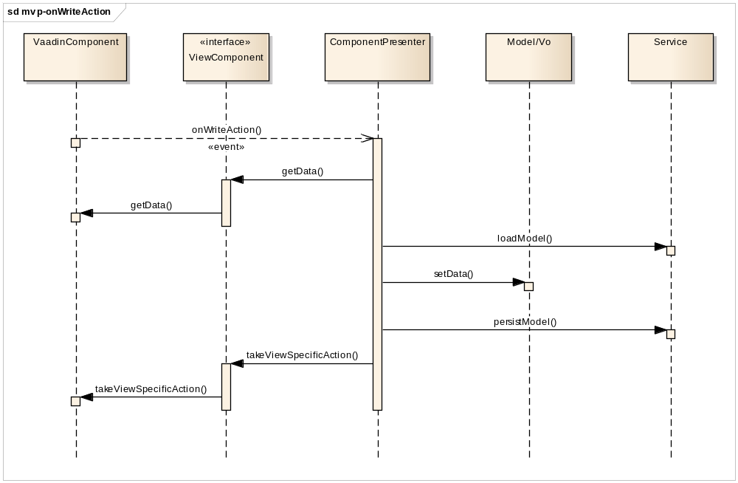
As we stated previously, the presenter also has the responsibility to decide about the following workflows: send global notifications to the UI and navigation to new views. The communication between the presenter and the components handling these cases is made via events as shown in the below diagram.
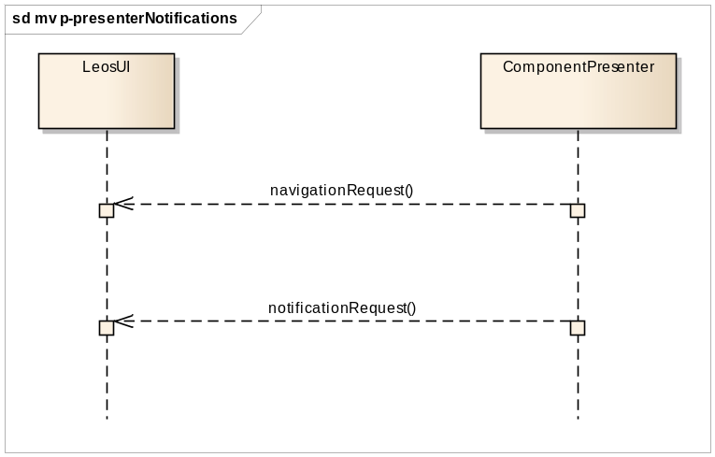
The component handling these actions is a component playing the role of a front-end controller, in our case, the Vaadin UI component (LeosUI).

JavaScript
The article edition is implemented using CkEditor. Besides the CkEditor library, we are providing an extension of CkEditor in order to enhance it with functionality that fits the purpose of AkomaNtoso XML document edition. Since it is clear that the javascript will continue to enlarge, it is very important to maintain a clean structure for the files and a clear architecture for the CkEditor extension we provide.

Structure
The JavaScript files for CKEditor edition feature are separated from the leos-web module and are placed under leos-editor module. The leos-editor module will be included as an overlay to the leos-web module after the build. The leos-editor module consists of the following structure:-

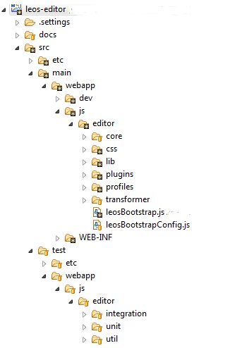

As it is clear from the image above, directly under the leos-editor folder we have src/main/webapp/js/editor. Under editor folder, we have:
- lib folder – consists of all the distributions used out of the box for e.g. (CKEditor, jQuery, requirejs, stampit, jsTree, lodash etc.)
- profiles folder – consists of the editor profile configuration files.
- transformer – encapsulates all the files related to akn-to-html transformations.
- core – consists of the common logic used across the editor.
- plugins folder – encapsulates all the custom plugins specifically designed for edition functionality for akn elements like: paragraphs, subparagraphs, points, alinea etc. It also consists of additional plugins like: table support, cross-references, authorial note, comments, highlights etc.
- test folder – consists of all the jasmine spec tests (Integration and unit).
- leosBootstrap.js – Implementation of CKEditor and all the javascript bootstrap logic.
- leosBootstrapConfig.js – Bootstrap configuration is specified in this file.

Implementation strategy
There are two main areas where implementation is done: Plugin and Transformer.
Plugin implementation works as plug-n-play. If the plugin is loaded in the profile the feature will be available for the editor. There are two types of plugins used in Leos.
- Ckeditor internal plugins, which comes with the distribution of ckeditor library.
- Custom plugins, which are implemented to support the edition and transformation from
akn to html and vice-versa. The plugin consists of transformation configuration used by
the transformer and additional logic.

Transformer encapsulates the logic to transform an element from akn-to-html and vice-versa based on the transformation configuration provided to it as input from the custom plugins.

Styles
All styles related files (css, scss, images, icons) are located under webapp/VAADIN/themes/leos. There are two types of styles: those related to our VAADIN components and those related to the content of the documents. The styles for document content are written directly in css files. The styles for VAADIN components are written in scss files and grouped by screen or usage. The below image shows this grouping and division.
